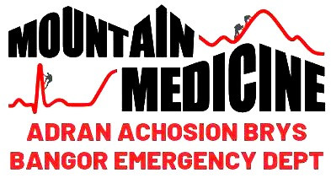

The Epidemiology of Scrambling Related Injuries in the Mountains of Snowdonia

Words: 4693

Cardiff University

Emergency, Prehospital and Immediate Care iBSc

The Epidemiology of Scrambling Related Injuries in the Mountains of Snowdonia

Abstract

Background
Scrambling is popular sport which encompasses elements of hillwalking and rock-climbing. There is a wealth of data on hillwalking and rock-climbing injuries, but little existing research on scrambling injuries. This study aims to identify patterns of scrambling injuries to aid preparation of the patients’ arrival to the Emergency Department (ED).

Methods
A single-centre retrospective cross-sectional study was conducted in a North Wales ED, using the Mountain Medicine Database. Injuries were scored by anatomical area and severity. The primary outcome was identification of the injured anatomical areas. The secondary outcomes included maximum Injury and Illness Severity Classification (IIC) score.

Results
Between 2004-2020, 140 scrambling patients were identified. The lower limb was the most injured region with 72.7% of patients having a lower limb injury of any severity. The median maximum IIC score was two. Male sex and a fall from height were found to increase maximum IIC.

Conclusion
Lower limb injuries were the most common. Severity of injury was increased by falls from a height and male sex. Pre-alerts mentioning fall from a height should warrant a trauma call in the ED. A lower threshold should be adopted for initiating a trauma call in male scrambling patients.

Contents

Abbreviations and Glossary 4

Background 5

Methods 8

Results 9

Discussion 15

Acknowledgements 17

References 18

Abbreviations and Glossary

Abbreviations
Term | Meaning
BMC | The British Mountaineering Council
ED | Emergency Department
IIC | Injury and Illness Severity Classification
Maximum IIC | Score given to patient relating to their injury or illness with highest severity score
MedCom | Medical Commission (of the International Climbing and Mountaineering Federation)
MMD | The Mountain Medicine Database
MRT | Mountain Rescue Team
OSICS-10 | The Orchard Sports Injury Classification System version 10
SAR | Search and Rescue
UIAA | The International Climbing and Mountaineering Federation (also known as Union Internationale des Associations d’Alpinisme)
UK | United Kingdom

Background

Scrambling and other Mountain Sports
Once a grey area in the world of mountaineering, scrambling has emerged as a sport in its own right. (1) The British Mountaineering Council (BMC) defines scrambling as a mixture of hillwalking and rock-climbing, whereby as the route becomes steeper, the difficulty of the scramble increases, and the more skills and equipment become necessary. (2) While many mountains have well established walking routes and popular steep climbing faces, scrambling offers the mountain-goer an alternative, more varied route. (1) It should be noted that scrambling is a British term and is viewed as a part of the wider category of mountaineering in other countries.

Grading of climbing, mountaineering, and scrambling is different between countries, with various scales used. (3) In the United Kingdom (UK) scrambles are generally graded from 1 to 3 to give the scrambler an idea of how hard the terrain will be to traverse (table 1). The grading system itself is not perfect; changing weather conditions can transform the difficulty of a scramble. The exposure of a scramble can also vary, with distances a scrambler is able to fall being greater for some routes. (2) Scrambling is part of a wider spectrum of walking, adventurous walking, scrambling, and climbing. To differentiate a hill-walk from a scramble it is generally accepted that there is a need to use both hands and feet to keep the scrambler moving forward. (4) On the other hand, differentiating a hard scramble from a rock-climb can be challenging, especially as a grade 3 scramble is deemed equivalent to a moderately graded rock-climb in the UK. (4)
Table 1: UK Grading of Scrambles.
Grade | Description
1 | Exposed walking route that requires both hands and feet. Can be generally attempted without ropes.
2 | Scrambler needs confidence moving over exposed but relatively easy climbing terrain. May need rope for protection.
3 | Only to be attempted by the confident scrambler/ climber. Use of rope expected.
(4)

Along with variation in difficulty of routes, there is a range in ability of mountain-goers. Scrambling is seen by some as a more accessible version of climbing. Routes may be attempted by people lacking in technical climbing knowledge and specialist equipment, as well as experienced climbers and scramblers. (5) The absence of ropes and protection could be because the individual is an experienced mountaineer or an inexperienced scrambler who has strayed above their skill level. (5)

Snowdonia National Park and the Mountain Medicine Database
Scrambling is one of many sports available to mountain-goers in Snowdonia National Park. As a major tourist attraction of North West Wales, Snowdonia boasts around 10 million visitor days every year and covers 2,176 square kilometres. (6) Popular scrambles include Tryfan North Ridge and Snowdon’s Crib Goch ridge. Both these routes are increasing in popularity every year and in 2018 both attracted over 25,000 visitors. (7, 8)

The Mountain Medicine Database (MMD) keeps a record of all patients arriving at Ysbyty Gwynedd Emergency Department (ED) after contact with either the Mountain Rescue Team (MRT) or Search and Rescue (SAR) helicopter, that were undertaking mountain activities in Snowdonia National Park. For each entry, information on the demographics of the patient, the time and location of the incident, and the pre-hospital and hospital diagnoses are collated. The database goes back to 2004 and is a world leading record of mountain casualties with hospital diagnoses. A 2013 study using the MMD, (9) found that 7% of casualties in Snowdonia were injured during scrambling activity.

UIAA Medical Commission Injury Classification
The International Climbing and Mountaineering Federation (UIAA) represents the climbing and mountaineering community worldwide. The UIAA Medical Commission (MedCom) set out a protocol for recording illnesses and injuries using a standardised system for all mountain sports. (10)

The UIAA (10) defines an injury as: “Any physical complaint due to an external or internal force sustained by a participant during trekking, mountaineering, or climbing activity”. An illness is defined by the UIAA (10) as “any affliction to a participant during trekking, mountaineering, or climbing, including during ascent and descent to the climb and camp time for expeditions”.

Injury location is classified using the Orchard Sports Injury Classification System version 10 (OSICS-10). (10) This is a 4-character coding system that categorises injuries based on anatomical location and pathology; the body area coding is displayed in table 2. (10, 11) Secondly, the Injury and Illness Severity Classification (IIC), also known as the UIAA MedCom score, is determined for each injured body part (table 3). (10) The IIC is decided retrospectively, considering the patient outcome and mortality. (10) The third component is fatality risk which considers difficulty and risk of the climbing route which can be evaluated by the case fatality rate. (10) The case fatality rate is calculated as the ratio of deaths within a population of people, such as passes of a route, during a set time frame. (10)

Table 2: Orchard Sports Injury Classification System for coding of body areas
OSICS body area character | H | N | S | U | E | R | W | P | C | D | O | B | L | G | T | K | Q | A | F | X
Category | Head/ Face | Neck/ Cervical spine | Shoulder/ Clavicle | Upper arm | Elbow | Forearm | Wrist | Hand/ Finger/ Thumb | Chest (sternum/ribs) | Thoracic spine | Trunk, Abdomen | Lumbar spine | Pelvis, Buttock | Hip/ Groin | Thigh | Knee | Lower Leg | Ankle | Foot/ Toe | Location unspecified
Main Grouping | Head and neck |  | Upper limbs |  |  |  |  |  | Trunk |  |  |  |  | Lower Limbs
(10, 11)

Table 3: Injury and Illness Severity Classification – UIAA MedCom IIC Score
IIC Score | Headline Description | Detailed Description
0 | No injury or illness.
1 | Mild injury or illness. | No medical intervention necessary, self-therapy.
2 | Moderate severe injury or illness. | Not life threatening. Prolonged conservative or minor surgery, outpatient therapy. Doctor attendance within days. Injury-related work absence. Heals without permanent damage.
3 | Major injury or illness. | Not life threatening. Hospitalisation, surgical intervention necessary. Immediate doctor attendance necessary. Injury-related work absence. Heals with or without permanent damage.
4 | Acute mortal danger; alive. | Polytrauma, immediate prehospital attendance, acute surgical intervention. Outcome: alive with permanent damage.
5 | Acute mortal danger; death. | Polytrauma, immediate prehospital attendance, acute surgical intervention. Outcome: death.
6 | Immediate death
(10)

Literature Search
A literature search was completed using Scopus because the database has European origin, and it is the largest database of worldwide literature. The terms “injur*”, “trauma”, “rock climb”, “mountaineer*”, “hill walk” were used. The term “scrambl*” was not used as it brought up no relevant papers and added many irrelevant papers to the search, therefore “mountaineer*” was used instead. This suggests a lack of focus on scrambling in existing literature, perhaps due to the limited use of the term outside of the UK.

The literature search found 16 articles of original research looking at a range of rock-climbing, hillwalking, and mountain rescues and one review. Five studies were in the UK with other studies located in North America, Austria, Switzerland, and Australia.

There is a male predominance in the literature with an average of 70.1% identifying as male. (5, 9, 12-20) Casualties were found across a spectrum of ages from infants to centenarians, with a mean age of 37 years old. (9, 13, 14, 16, 18-20) Summer was found to be the most frequent season for incidents to happen in the mountains, and Saturday and Sunday have been demonstrated as the most common days of the week. (5, 14, 19) A study of UK mountain rescues, (19) found that 77.2% of patients that were rescued and needed medical attention were injured. Of these the body areas injured were the lower extremity (53%), head (13.1%), and arm (10.1%). (19) Illnesses accounted for 10.4% of casualties, with suspected cardiac events most common (28.7%) followed by overdose and attempted suicide (12.2%), and seizures (8.2%). (19)

In previous studies, scrambling has been found to account for an average of 6.1% (range 3-10%) of mountain casualties. (9, 13, 19, 21) A study of Canadian mountain rescues, (21) found while 4.4% of casualties were involved in scrambling at the time of accident, 5% of the overall fatalities were found to be due to scrambling. A study of climbing accidents in Australia, (22) observed that 4.2% of all injuries classed in severity serious, severe, or fatal were due to scrambling, yet 12% of the fatalities were found to be due to scrambling. These suggest scrambling have a higher proportion of fatalities relative to the number of people injured during scrambling, compared to other mountain activities. Rugg et al. (14) compared roped and non-roped rock-climbing injuries to suggest a pronounced relative mortality increase when climbing rope free. This study was done in Austria and did not comment on the grade of rock-climbs, so may include patients on higher grades than scrambling terrain. (14)

There is a lack of data published specifically looking at scrambling injuries, but there are many articles on injuries in related mountain sports. Because scrambling has elements overlapping with hillwalking and rock-climbing, it could be hypothesised that scrambling injuries follow a similar pattern to one or both sports.

Hillwalking, defined by the BMC (2) as: “walking over mountainous terrain”, requires navigation skills, warm clothes, and supportive boots. Compared to scramblers, hillwalkers are less exposed while on the mountains and use easier routes. Hillwalking has been found to be associated with injuries to the lower extremities. (18, 23) Other reasons for the need of medical attention in hillwalkers were found to be non-traumatic illnesses, falls and being under-prepared. (23, 24)

Rock-climbing encompasses multiple activities, which can be indoors or outdoors, including bouldering which is often to 2-3 metre heights, technical roped climbing with harnesses and protection, and rope free climbing. (5) Outdoor rock-climbers are more likely to use ropes and protection compared to scramblers. Acute injuries in rock-climbing are often due to equipment failure or a fall and have been found to affect the lower extremity most commonly, especially the ankle. (5, 15, 20, 22, 25, 26) This is followed by head injury. (5, 14, 16, 22)

Aims and Objectives
The aim of this project was to help the ED prepare for incoming patients by describing the demographics and patterns in patients who present after an incident while scrambling. This project focused on those with injuries rather than illnesses while scrambling.

The objectives for this project were to:
- Describe the demographics of patients in the MMD.
- Grade the injuries of scramblers using the UIAA MedCom injury classification.
- Describe patterns in anatomical location of scrambling injuries.
- Describe the effect of age and sex of the scrambler on the severity of injuries seen.
- Describe the effect of the season on the severity of injuries seen.
- Describe the effect of falls and fall height on the severity of injuries seen.
- Describe patterns in fatalities seen in scramblers.
- Describe the impact of scrambling grade on the severity of injuries seen.
- Calculate the case fatality rate where possible.
- Describe patterns in illnesses seen in scrambling patients.
- Help the ED be more prepared for incoming scramblers with injuries.

Methods

Study Design
A single-centre retrospective cross-sectional study was conducted at Ysbyty Gwynedd ED between September 2020 to April 2021. This study used the MMD which is based in and prospectively collated at Ysbyty Gwynedd ED and has data from 2004-2020.

Population
Patients of any age who were in Snowdonia National Park, had contact with MRT or SAR, and were admitted to Ysbyty Gwynedd ED are included in the MMD. Patients found dead at scene or transferred directly to a major trauma centre are also included in the database. The activity the patient was participating in is recorded. This study included all patients in the database categorised as scrambling at the time of incident. Patients who self-presented to the ED after injury in the national park, without contact with MRT or SAR are not included in the database. Patients with inadequate documentation on review were excluded from this study.

Data Collection
The ED, pre-hospital, and if applicable post-mortem documentation for all the scrambling patients were reviewed by a medical student and an ED registrar jointly. Patients were categorised into illnesses and injuries. The severity of injuries was scored using the UIAA MedCom protocol for recording illnesses and injuries in table 2 and 3. Each illness was given a severity score (table 3). Every injury identified was given an IIC score allocated to the affected anatomical body area. A maximum IIC score for each of the four main body areas was given for each patient, based on the most severe injury in that body group. An overall maximum IIC score was then given to each patient based on the highest severity score present.

A fall from a height was defined in the MMD as a fall from greater than standing height. The presence of a fall from height was recorded in the database. Where the height of fall was estimated in the MRT, SAR, and ED documentation, all identified height estimates were recorded in the MMD. All estimates were converted into metres. A mean average was calculated where there were discrepancies in height estimate between those documented.

The location the patient was retrieved from was recorded in the MMD. An ED registrar, who is an experienced scrambler, graded the locations as per the BMC scrambling grades, shown in table 1. Where the recorded locations were not specific enough to allow grading, no grade was given. Using data from Snowdonia National Park Authority, (7, 8) the number of patients in the MMD rescued from popular scrambles were compared to the visitor monitoring figures. This data was also used to calculate the case fatality rate.

Outcomes
The primary outcome was the anatomical body location of injuries. This is recorded using OSICS (table 2). The secondary outcomes include the IIC score and the maximum IIC score. These were calculated using the UIAA MedCom protocol (table 3). The case fatality rate was another secondary outcome.

Statistical Analysis
Data was analysed and graphs produced using IBM SPSS Statistics 26 software package. A descriptive analysis evaluated patient demographics, anatomical location of injuries, and geographical location.

Data was tested for normality using a Shapiro-Wilk test, and was found to be not normally distributed. Mann-Whitney U tests were chosen to test differences in maximum IIC between sexes and to test the difference in maximum IIC between patients who had a fall from height and those who did not. Kruskal-Wallis H tests were selected to determine effect on maximum IIC by season and age. Spearman’s rank-order correlation was chosen to determine association between fall distance and maximum IIC, and to determine correlation between maximum IIC and the grade of scramble. Statistical significance was set at p<0.05.

Ethics
The MMD has ethical approval which is renewed on a yearly basis. This project uses the MMD and its existing ethical approval.

Results
The MMD had entries for 1683 patients over the period 30/01/2004 to 21/11/2020. The median (IQR) age of patients in the MMD was 40 (29) and 1040 (61.8%) of the patients were male (table 4). There were 141 patients listed in the database as scrambling. One scrambling patient had missing documentation so was excluded, leaving 140 scrambling patients included in the study. Scrambling patients had a median (IQR) age of 39 (28) and there were 99 (70.7%) male patients out of the 140 (table 4).

Table 4: Demographics of all patients in database and patients included in study
 |  | All patients n=1683 (%) | Scrambling patients n=140 (%)
Median age (IQR) |  | 40 (29) | 39 (28)
Sex | Male | 1040 (61.8) | 99 (70.7)
 | Female | 640 (38.0) | 41 (29.3)
 | Unknown | 3 (0.2) | -
Season | Winter | 206 (12.2) | 11 (7.8)
 | Spring | 482 (28.6) | 47 (33.6)
 | Summer | 575 (34.2) | 49 (35.0)
 | Autumn | 420 (25.0) | 33 (23.6)
Outcome | Alive | 1572 (93.4) | 128 (91.4)
 | Death | 110 (6.5) | 12 (8.6)
 | Unknown | 1 (0.1) | -
Nature of complaint | Injury | 1393 (82.8) | 132 (94.3)
 | Illness | 284 (16.9) | 8 (5.7)
 | Unknown | 6 (0.3) | -

Illness accounted for eight (5.7%) of the 140 scrambling patients, more than 10% less than for the whole of the database (table 4). The severity of illnesses ranged from one to six on the MedCom IIC score. Reasons for illness included coronary heart disease, migraine, and self-harm.

Anatomical Location of Injuries
A total of 455 injuries were identified on 132 injured patients. Of the 132 patients, the most common individual body part to be injured was the head with 60 (45.5%) patients. This was followed by the: knee 42 (31.8%), chest 34 (25.8%), ankle 33 (25%), and elbow 31 (23.5%). Body areas were grouped anatomically, and the severity score being given for the patient’s most severe injury in that body region. The lower limb was found to be the most commonly injured body area, with 96 patients (72.7%) out of 132 injured patients having an injury of any severity to the lower limb, followed by the upper limb with 72 (54.5%) patients (Table 5).

Table 5: Patient Injuries according to anatomical location and injury severity score ª with a mean IIC for each body area
Body Area | UIAA MedCom IIC score |  |  |  |  |  | Mean IIC score
 | 1 | 2 | 3 | 4 | 5 | 6
Head and Neck n=65 | 18 | 33 | 2 | 1 | - | 11 | 2.46
Upper Limbs n=72 | 33 | 22 | 17 | - | - | - | 1.78
Trunk n=58 | 30 | 9 | 10 | 3 | - | 6 | 2.17
Lower Limbs n=96 | 50 | 25 | 21 | - | - | - | 1.70
Total | 131 | 89 | 50 | 4 | - | 17
ª Colour to represent frequency with red the most and green the least common.

Severity of injuries
Severity of injuries using the UIAA MedCom IIC score was recorded, and each patient given a maximum IIC score based on their most severe injury. The median (IQR) maximal IIC score across all the injured patients was two (1), with two also being the mode maximum IIC score (table 6).
The number of patients with no injuries scored greater than one, on the UIAA MedCom IIC score, was 24 (18.2%) out of 132 patients with injuries (table 6). These patients were deemed as needing no medical attention.
Table 6: Demographics by maximum IIC
Maximum IIC score | Number of patients | Mean age (years) | Fall from height (%) | Male (%) | Female (%)
1 | 24 | 35 | 11 (46) | 13 (54) | 11 (46)
2 | 57 | 42 | 34 (60) | 39 (68) | 18 (32)
3 | 36 | 39 | 26 (72) | 29 (81) | 7 (19)
4 | 4 | 35 | 4 (100) | 3 (75) | 1 (25)
5 | - | - | - | - | -
6 | 11 | 45 | 11 (100) | 9 (82) | 2 (18)

While males are more predominant throughout, there was an increase in the proportion of male patients as the maximum IIC score increased (table 6). Figure 1 shows equal median, minimum and maximum scores between the sexes. The upper and lower quartiles for male patients are greater than those for females. This could suggest a slight increase in maximum IIC score for males compared to females. A Mann-Whitney U test was chosen to compare differences in the maximum IIC between the two sexes, to determine if males have injuries significantly more severe than females. It was found that the maximum IIC in males was significantly higher than in females (U=1382.500, p=0.0019).
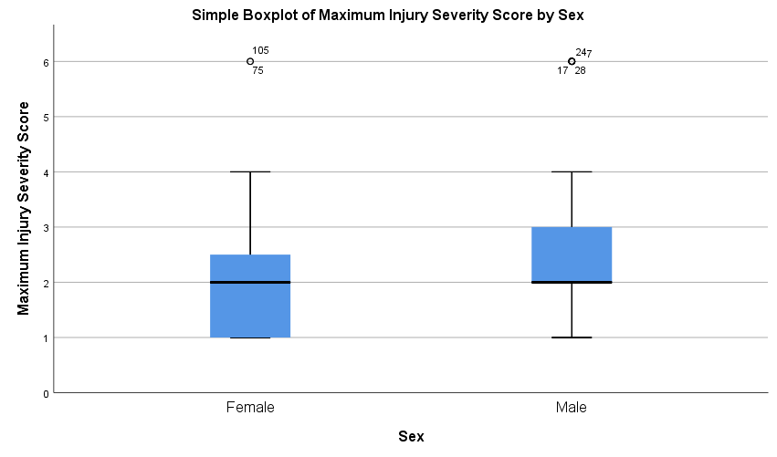
Figure 1: Maximum injury severity score in females and males. Figure suggests slight increase in injury severity in males compared to females. Maximum injury severity score based on the most severe injury found.

There is little variation seen in mean age for each of the maximum severity scores (table 6). Figure 2 was plotted to visualise any variation between age groups and the maximum IIC score. Patients were sorted into 20-year categories to group paediatric patients and young, middle, and older adults, due to difference in physiology and behaviour. The figure shows equal median scores across all 4 age groups and little variation in quartiles. A Kruskal-Wallis H test showed that there was no statistically significant difference in maximum IIC score between the different age groups (X²(2) =0.529, p=0.913), with a mean rank maximum IIC score of 64.75 for under 20 years, 64.80 for 20-39 years, 69.24 for 40-59 years, and 69.60 for 60 years and over.

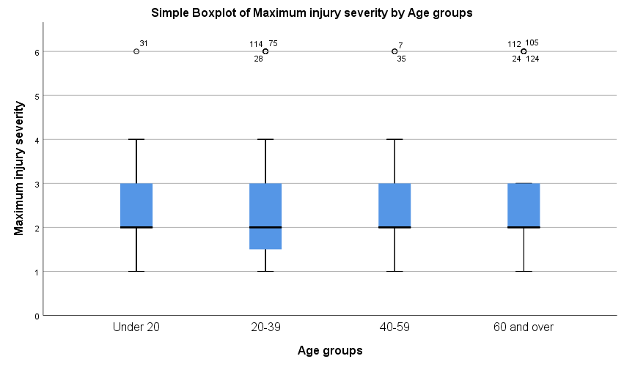
Figure 2: Maximum injury severity score in different age groups. Figure suggests no difference in maximum injury severity between the groups. Maximum injury severity score based on the most severe injury found.

Scrambling injuries presented most frequently in the spring and summer (table 4), with seasons each including 3 months (e.g., winter defined as December, January, February). Figure 3 compares the maximum IIC scores across the seasons showing the upper and lower quartiles are equal for all seasons. Spring, summer, and autumn have equal median, maximum and minimum scores. From the figure, no season appears to have significantly different maximum IIC scores. A Kruskal-Wallis H test was performed to determine whether the maximum IIC score was related to the season, which found no statistically significant difference (X²(3) =0.388, p=0.943), with a mean rank max IIC score of 71.00 for winter, 66.16 for spring, 65.19 for summer, 69.23 for autumn.
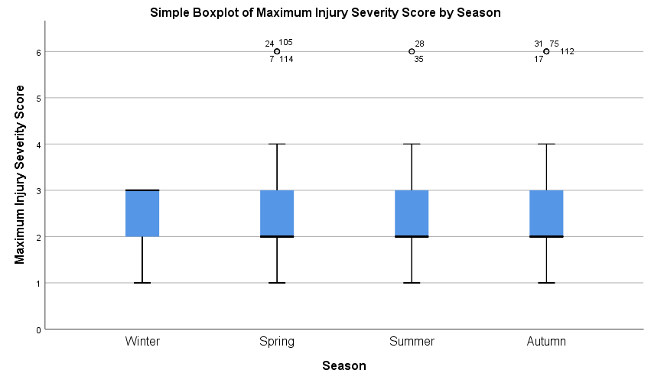
Figure 3: Maximum injury severity scores across the seasons. Figure suggests no difference in maximum injury severity between the groups. Maximum injury severity score based on the most severe injury found.

A fall from a height was associated with injury in 86 patients (65.1%) out of 132 with injuries. All patients with a maximum IIC score of four or more had a fall from height (table 6). Figure 4 shows equal median values for fallers and non-fallers, but the higher upper quartile, maximum, and positive skew of the faller plot suggests an increase in maximum IIC score in fallers compared to non-fallers. A Mann-Whitney U test was performed to see if there was a statistical relationship between a fall and maximum IIC which found that the maximum IIC was significantly higher in the patients who had a fall compared to those who did not (U=1342.000, p=0.001).

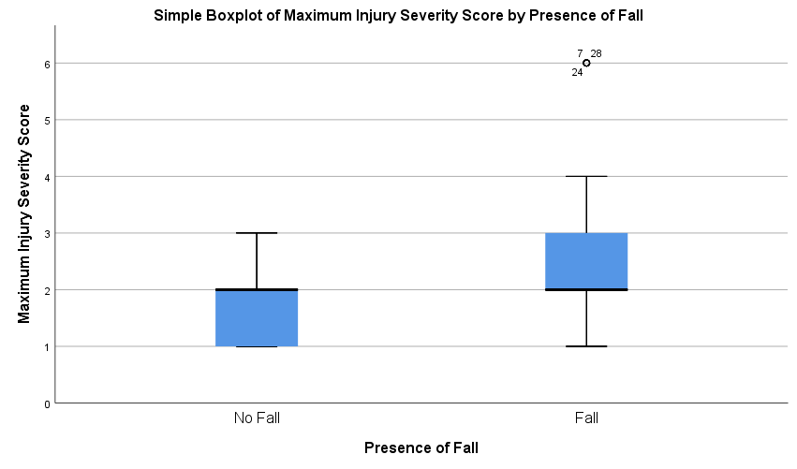
The height of the fall was documented for 77 patients (90%) of the 86 patients who fell. A Spearman’s rank-order correlation was run to determine the relationship between the distance of the fall and the maximum IIC. There was a strong positive correlation between the distance of the fall and the maximum IIC which was statistically significant (r_{s}(71)=0.232, p=0.048).
Figure 4: Maximum injury severity scores in patients who had fall from height and those who did not. Figure suggests slight increase in maximum injury severity score in patients with fall. Maximum injury severity score based on the most severe injury found. Fall from height defined as fall from height greater than standing height.

Of the 140 scrambling patients there were 12 (8.6%) who were dead at scene, one due to illness. Of the traumatic deaths, all 11 were related to a fall. All 11 of the traumatic deaths suffered fatal head and neck injuries, and six had concurrent fatal trunk injuries.

Geographical Location and Grade of Scramble
Patients came into the ED from a wide range of scrambling locations across Snowdonia. Out of all the scrambling patients, 123 patients had enough information recorded on the location of the incident to determine the grade of the route. The most common routes were low grade with 100 patients (81.3%) of the 123 scramblers on a grade-1 route. A Spearman’s rank-order correlation was run to determine the relationship between the grade of scramble and the maximum IIC. There was no correlation between the grade and the maximum IIC (r_{s}(112)=0041, p=0.665).

Crib Goch, a grade-1 scramble, was the route 54 patients (43.9%) were on, making it the most common place for a scrambling injury. Visitor monitoring data from Snowdonia National Park Authority in 2018 calculated a mean of 19,324 visits a year to Crib Goch between 2013-2018. (7) A mean of 3.5 patients per year involved in incidents on Crib Goch was observed in this study during the same period. This study found seven deaths on Crib Goch over 16 years. Using the visitor data available from 2007-2018 this translates to a case fatality rate of one death per 29,864 passes of Crib Goch. (7, 8)

Discussion
In this single-centre retrospective cross-sectional study of scrambling injuries, the lower limb was the most affected body region. Male sex and increasing fall height increased the risk of a higher severity of injury. Mortality for scramblers was less than 10%. Most patients were on a grade-1 scramble at the time of injury.

Patient demographics in this study, namely age and gender, were comparable to those included in the literature search for mountain sport casualties. (5, 9, 12-20) Literature suggested the lower limb was the most affected body region for both rock-climbing and hillwalking. (5, 15, 18, 20, 22, 23, 25, 26) This study found scrambling to also affect lower limbs most frequently.

The limbs were injured to a low severity, with both the upper and lower limbs having mean maximum IIC scores below two. More than half of the lower limb injuries did not require medical attention, suggesting that although lower limb injuries are common, they are generally not severe. The head and neck, and the trunk had higher mean IIC scores indicating that the more severe injuries were found in these areas. Patients with no injuries requiring medical intervention accounted for 18.2% of those seen. These patients were seen to by MRT or SAR, as well as the ED but needed no medical treatments. Although this may be seen to suggest inappropriate use of services, it is important to note that even minor injury in a dangerous location can decrease confidence and render a scrambler unable to carry on, thus making a rescue necessary. Equally due to the nature of scrambling requiring all four limbs, even a minor limb injury would make continuing the route difficult. This may explain why there are so many low severity limb injuries.

Males were found to have significantly higher severity injuries than females. It is not clear from this study why this is. One factor not found to influence the severity of injuries was season. This tells us that all year round the ED can expect to see patients of all severities presenting but are more likely to see patients present in the summer and spring. Scrambling injuries presented across a wide array of age groups. Injuries with high and low severity featured in each group and no significant difference in max IIC was found between age groups. It is recommended that all age groups should be assessed with the same level of suspicion for severe injury.

Falls were found in the literature to be a leading cause of acute injuries in rock-climbers. (15, 26) This study found the same for scramblers, with over half the injured patients involved in a fall from a height greater than standing. The analysis found that patients who fell from a height had a significantly higher maximum IIC score than those who did not. The study also found the height of the fall positively correlated with the maximum severity of injuries. These findings fit with the physics of the injuries. The further a scrambler falls, the velocity increases due to gravity, and the greater in impact on landing. Injuries not related to a fall from height will generally be low impact therefore have a lower severity.

The study had a low number of patients who died therefore few conclusions can be drawn. However, it should be noted that all traumatic deaths in the study were from falls, fitting with the results that falls are associated with higher severity injuries. The cause of instant death was head and neck injuries for all the traumatic deaths with half of these also having fatal trunk injuries. The head and trunk are therefore the areas in need of the most protection when scrambling.

Most patients in the study were on grade-1 scrambles. These routes are the ones most accessible to non-experienced scramblers, therefore may be likely to have more visitors than more advanced routes. Grade-1 scrambles are generally viewed as routes not needing ropes or protection. The lack of protection and increased likelihood for scrambling novices on low grade routes may explain why there is no difference in injury severity in low grade routes compared to higher grades.

Future research could look at the use of protective equipment and its effect on injuries. In this study, no record was made of whether helmets, ropes, or other safety equipment was in use by the scrambler. As fatal head injuries were found to be the main cause of death in scramblers, it would be interesting to see if helmet use affects outcome. It may be that the nature and distance of some falls would cause death whether a helmet was worn or not. Information on helmet use could be gained from pre-hospital responders and included in the MMD for future patients. Skill level of scramblers was not measured in this study. Future research could assess whether novices or experienced scramblers had worse outcomes. Patients who present from MRT or SAR could be asked about their skill level and documented in the hospital notes as it is likely these patients will be added to the database. This would however only include patients able to communicate after their injuries.

Limitations
This study looked at patients brought into the ED after contact with MRT or SAR. Therefore, patients who were injured on the mountains but were able to self-evacuate and later presented to the ED were not included in the database. Some low severity injuries may therefore be missing, especially non-lower limb injuries as these patients are able to walk themselves off the route. This would mean the database is not complete and there are more injured scramblers in Snowdonia than this study suggests.

The distance of falls was estimated. There were discrepancies between some documented distances in pre-hospital and hospital documentation. It would not be feasible to formally measure fall distances.

The small sample size of scrambling patients meant that analysis of sub-groups had higher likelihood of random error. This could be addressed by establishing and conducting a similar mountain medicine surveillance register in other emergency departments receiving patients with scrambling injuries such as the Peak District and Lake District.

Implications
The risk factors found for a higher severity of injury were a fall from height and male sex. This information should be given in the pre-hospital pre-alert along with the clinical findings. A lower threshold should be adopted to patients who have had a fall from a height for a trauma call, to ensure specialists are ready for patient arrival. This will allow severe injury to be quickly treated or ruled out. Head and neck injuries and trunk injuries also came with higher severities, so even though they are less common than lower limb injuries, these should be looked for more carefully.

Conclusion
In conclusion, this study found lower limb injuries to be the most common amongst scrambling patients, but head and trunk injuries were the most likely cause of death. Severity of injury was increased by a fall from a height, increasing height of the fall, and by male sex. Pre-alerts mentioning falls, and head and/or truncal injuries should warrant a trauma call in the ED. A lower threshold should be adopted for initiating a trauma call in male scrambling patients.

Acknowledgements
Thank you to my project supervisor RG, and SMK for their continuous support, guidance, and time throughout the project. Thank you also to EB for your help and advice.

References

1. Beedie P. Adventure tourism. Sport and adventure tourism. 2003:203-40.
2. British Mountaineering Council. Different Types of Mountaineering Activities Explained 2014 [cited 2020 04/11]. Available from: https://www.thebmc.co.uk/different-types-of-climbing-explained.
3. Draper N. 14 Climbing grades. The Science of Climbing and Mountaineering. 2016:227.
4. Lindon H. Scrambling skills: the grades explained British Mountaineering Council2015 [cited 2020 02/11]. Available from: https://www.thebmc.co.uk/understanding-scrambling-grades.
5. Lack DA, Sheets AL, Entin JM, Christenson DC. Rock Climbing Rescues: Causes, Injuries, and Trends in Boulder County, Colorado. Wilderness & Environmental Medicine. 2012;23(3):223-30.
6. Snowdonia National Park Authority. Snowdonia Facts and Figures 2016 [cited 2021 05/01]. Available from: https://www.snowdonia.gov.wales/addysg-education/facts-and-figures.
7. Snowdonia National Park Authority. Visitor Monitoring Figures. 2018.
8. Snowdonia National Park Authority. Visitor Monitoring Figures. 2013.
9. Hall BGRM, Dykes LKMF. Tourist Mountain: Mountain Casualties in Snowdonia. Wilderness & environmental medicine. 2013;24(1):81-2.
10. Schöffl V, Morrison A, Hefti U, Ullrich S, Küpper T. The UIAA Medical Commission Injury Classification for Mountaineering and Climbing Sports. Wilderness & Environmental Medicine. 2011;22(1):46-51.
11. Rae K, Orchard J. The Orchard Sports Injury Classification System (OSICS) Version 10. Clinical Journal of Sport Medicine. 2007;17(3).
12. Locker T, Chan D, Cross S. Factors Predicting Serious Injury in Rock-Climbing and Non–Rock-Climbing Falls. The journal of trauma. 2004;57(6):1321-3.
13. Kumar AJS, Gill DS, Fairweather C, Dykes L. The pattern of ankle fractures sustained by outdoor activities at the Snowdonia National Park, North Wales, United Kingdom. Foot and ankle surgery. 2008;15(3):144-5.
14. Rugg C, Tiefenthaler L, Rauch S, Gatterer H, Paal P, Ströhle M. Rock Climbing Emergencies in the Austrian Alps: Injury Patterns, Risk Analysis and Preventive Measures. International journal of environmental research and public health. 2020;17(20):7596.
15. Mugleston B, McMullen C. Musculoskeletal Injuries in Climbers. Current Physical Medicine and Rehabilitation Reports. 2019;7(3):179-85.
16. McDonald JW, Henrie AM, Teramoto M, Medina E, Willick SE. Descriptive Epidemiology, Medical Evaluation, and Outcomes of Rock Climbing Injuries. Wilderness & Environmental Medicine. 2017;28(3):185-96.
17. Bernard M, Wright R, Anderson H, Bernard A. Wilderness Falls: An Analysis and Comparison of Rock Climbers and Nonclimbers. Journal of Surgical Research. 2019;234:149-54.
18. Faulhaber M, Ruedl G, Schneider F, Walter D, Sterr R, Schobersberger W, et al. Characteristics of Victims of Fall-Related Accidents during Mountain Hiking. International journal of environmental research and public health. 2020;17(3):1115.
19. Mort AJ, Godden DJ. UK mountain rescue casualties: 2002–2006. Emergency Medicine Journal. 2010;27(4):309-12.
20. Buzzacott P, Schöffl I, Chimiak J, Schöffl V. Rock Climbing Injuries Treated in US Emergency Departments, 2008–2016. Wilderness & Environmental Medicine. 2019;30(2):121-8.
21. Curran-Sills GM, Karahalios A. Epidemiological Trends in Search and Rescue Incidents Documented by the Alpine Club of Canada From 1970 to 2005. Wilderness & Environmental Medicine. 2015;26(4):536-43.
22. Sedgman IB. Climbing Accidents in Australia. 2004.
23. Mort A, Godden D. Injuries to Individuals Participating in Mountain and Wilderness Sports: A Review. Clinical journal of sport medicine : official journal of the Canadian Academy of Sport Medicine. 2011;21:530-6.
24. Gatterer H, Niedermeier M, Pocecco E, Frühauf A, Faulhaber M, Menz V, et al. Mortality in Different Mountain Sports Activities Primarily Practiced in the Summer Season-A Narrative Review. International journal of environmental research and public health. 2019;16(20):3920.
25. Schweizer A. Sport climbing from a medical point of view. Swiss Med Wkly. 2012;142:w13688.
26. Jones G, Asghar A, Llewellyn DJ. The epidemiology of rock-climbing injuries. British Journal of Sports Medicine. 2008;42(9):773.

